** East West University**

**Course No: CSE109 Lab**

**Experiment Number:** 03

**Experiment Name:** Verification of Superposition Theorem

**Date of Experiment: 06/10/2016**

**Date of submission: 21/10/2016**

**Group: 5**

**ID: 2016-1-60-053**

**2016-1-60-057**

**2016-1-60-058**

**2016-1-60-060**

**Experiment number: 03**

**Experiment Name: Verification of Superposition Theorem**

1. **Objectives:** The objectives of this experiment is to verify the Superposition Theorem using laboratory experiment.
2. **Equipment/ Apparatus:**

* DC voltage source (01)
* Trainer board(01)
* Resistors (R1= 0.47 K,R2= 1k ,R3= 1.5 K)
* Multi-meter (01)
* Ammeter (01)
* Breadboard (01)
* Wires

1. **Experimental Setup:**

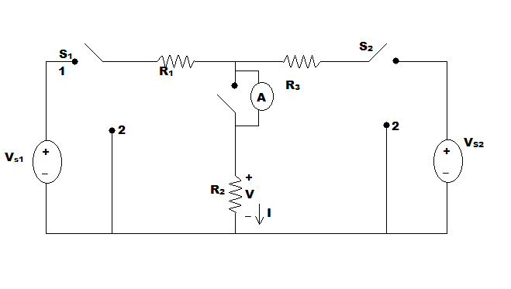

**Figure: 1**

1. **Procedure:**

* Measure the resistance of the resistors by using the multi-meter.
* Connect the circuit as shown in **fig.1** in breadboard keeping the positions of both of the switches S1 and S2= to 1. Use a DC voltage source for the **Vs1** a trainer board for source **Vs2**.
* Turn on the DC voltage source and measure is output voltage **VS1**by using the multi-meter. Adjust the voltage changing **KNOBs** of the DC voltage source such that the output voltage becomes **15V**. Similarly, turn ON the trainer board and measure its output voltage by using the multi-meter. Adjust the voltage changing **KNOBs**of the trainer board such that is output voltage becomes 12V.
* Connect the ammeter across switch **S** and then open the switch **S** and measure current **I** by using the ammeter. Close the switch S.
* Measure voltage V across the resistor R2 by using multi-meter.
* Remove the position of the switch S2 from 1 to 2.
* Open the switch S and measure current through the resistor R2 given by the ammeter. Close the switch.
* Measure voltage V across the resistor R2 by using multi-meter.
* Remove the position of the switch S1 from 1 to 2. Reconnect switch S2 from position 2 to 1.
* Open the switch S and measure current through the resistor R2 given by the ammeter. Close the switch.
* Measure voltage V across the resistor R2 by using multi-meter.
* Perform the calculations below.

1. **Data table:**

|  |  |  |  |  |  |  |  |  |  |  |
| --- | --- | --- | --- | --- | --- | --- | --- | --- | --- | --- |
| **R1 (K)** | **R2 (K)** | **R3 (K)** | **VS1**  **(Volt)** | **VS2**  **(Volt)** | **I (mA)** | **V**  **(Volt)** | **I1**  **(mA)** | **V1**  **(Volt)** | **I2 (mA)** | **V2**  **(Volt)** |
| **0.464** | **0.983** | **1.471** | **15.00** | **10** | **11** | **10.52** | **8** | **8.43** | **2** | **2.09** |

1. **Calculations:**

* I1+I2 = 8+2 = 10 A
* 100*(I-(I1+I2))/I = 100 * (11 - (8+2)) / 11 = 9.09
* V1+V2= 8.43 + 2.09 = 10.52 V
* 100*(V-(V1+V2))/ V= 100 * (10.52- (8.43+2.09)) / 10.52 = 0

**7. Questions & Answers:**

(i) Do the experiment results verify the Superposition theorem ? Why are you getting some discrepancies ?

**Answer:** From Superposition theorem we know,

"*The current through, or voltage across, an element in a linear bilateral network is equal to the algebraic sum of the currents or voltages produced independently by each source.*"

When the current flows through R2 is I1 ,

I'1 = Vs1/ [{R3*R2/(R3+R2)}+R1] = 14.54 A.

I'2= I'1*{R2/(R3+R1)} = 7.22 A

From superposition theorem, I1=I'1-I'2 = 7.32 A

When the current flows through R2 is I2 ,

I''2 = Vs2 / [{R1*R2/(R1+R2)}+R3] = 5.60 A

I''1 =I''2 *{R2/(R2+R1) } = 3.71

Superposition theorem, I1=I''2-I''1 = 1.89 A

I=I1+I2= 9.21 A

So, we see there are some little difference between these two and it verifies Superposition theorem.

We got some discrepancies because of ammeter, which is measuring very low current of circuit and also for the environment.

(ii) Theoretically determine the value of **I** , **V** , **I1**, **V1** , **I2** and **V2** ?

**Answer:**

When the current flows through R2 is I1 ,

I'1 = Vs1/ [{R3*R2/(R3+R2)}+R1] = 14.54 A.

I'2= I'1*{R2/(R3+R1)} = 7.22 A

From superposition theorem, I1=I'1-I'2 = 7.32 A

V1=I1R2 = 7.20 V

When the current flows through R2 is I2 ,

I''2 = Vs2 / [{R1*R2/(R1+R2)}+R3] = 5.60 A

I''1 =I''2 *{R2/(R2+R1) } = 3.71

Superposition theorem, I2=I''2-I''1 = 1.89 A

I=I1+I2= 9.21 A

V2=I2R2= 1.85 V

V=V1+V2=9.05 V

**8. Discussion:**

(i) For measuring current we have to use the exact value of ammeter Errors less than 10-3 will be ignored.

(ii) Measuring the resistance of resistors we have to remember that human hand can effect on the value of resistance. We have to avoid them.

(iii) When calculating data we should be very careful for approximate values.